

OWNERS MANUAL
FOR POPCORN MACHINE PEDESTAL BASE

MODEL:
PEDESTAL BASE
Fits 4 or 6 ounce Metropolitan Poppers

PART NUMBER:
30050

INCLUDED:
PARTS LIST
ASSEMBLY INSTRUCTION
WARRANTY INFORMATION

Benchmark USA Inc. ● 25-J Brookfield Oaks Dr. ● Greenville, SC 29607 ● T: 864-312-5500 ● F: 864-312-5505

PARTS LIST
Part # / Item | Description | Quantity
354 / 1 | Top shelf (has four holes on surface) | 1 piece
355 / 2 | Middle shelf (has square hole for magnet) | 1 piece
356 / 3 | Bottom shelf (has brackets for casters) | 1 piece
351 / 4 | Left side panel  (has holes for hinge attachment in wider lip) | 1 piece
352 / 5 | Right side panel | 1 piece
353 / 6 | Back panel | 1 piece
357 / 7 | Door | 1 piece
358 / 8 | Hinge | 3 sets
359 / 9 | Handle | 1 piece
360 / 10 | Casters | 4 sets
361 / 11 | 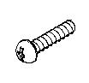  M5 X 6mm Sheet metal screws | 38 pieces
361 / 12 | Handle support plate | 1 piece
361 / 13 | Magnet | 1 piece
361 / 14 | M4 X 10mm Screws | 12 pieces
361 / 15 | 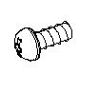  M4 X 8mm Screws | 2 pieces
361 / 16 | M4 X 10mm Screws | 4 pieces
361 / 17 |   M4 Nut | 4 pieces

To order Parts Contact:
Benchmark USA, Inc.
25-J Brookfield Oaks Dr.
Greenville, SC 29607 USA
Tel: 877-432-5500
Fax: 864-312-5505
Email: parts@benchmarkusainc.com
Pedestal Assembly
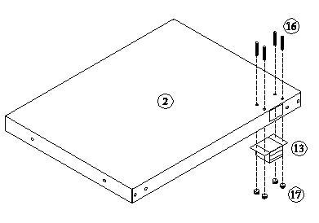
Figure 1
Attach the magnet (13) to middle shelf (2) with 4 pieces screws (16) and nut (17). As shown in Figure 1

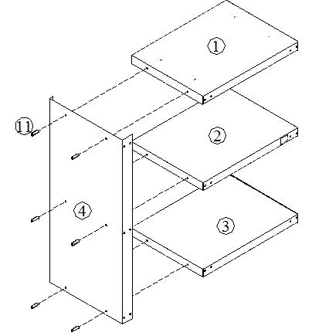
Figure 2

Assemble the pedestal by attaching the left side panel (4) to the top shelf (1), middle shelf (2) and bottom shelf (3) using the 6 pieces of enclosed sheet metal screws (11). As shown in Figure 2
DO NOT TIGHTEN THE SCREWS UNTIL FULLY ASSEMBLED
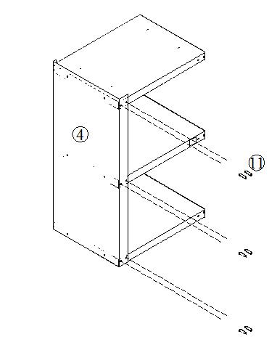
Figure 3
Attach another 6 sheet metal screws (11) for front portion of left side panel (4). As shown in Figure 3

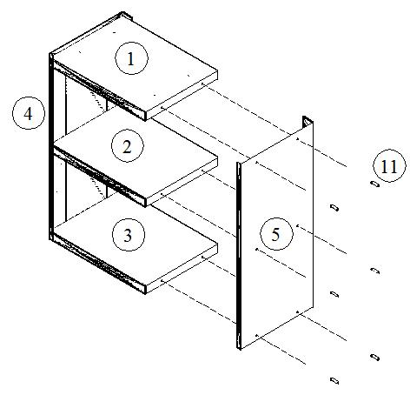
Figure 4
Attach the right side panel (5) to the top shelf (1), middle shelf (2) and bottom shelf (3) using another 6 of the enclosed sheet metal screws (11). As shown in Figure 4.
DO NOT TIGHTEN THE SCREWS UNTIL FULLY ASSEMBLED
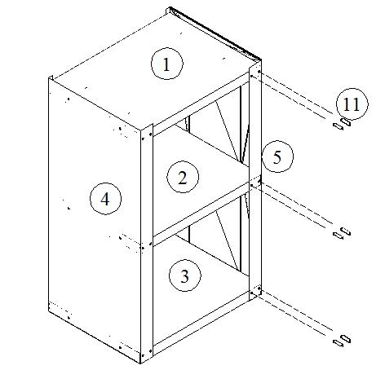
Figure 5
Attach 6 sheet metal screws (11) for front portion of right side panel (5). As shown in Figure 5

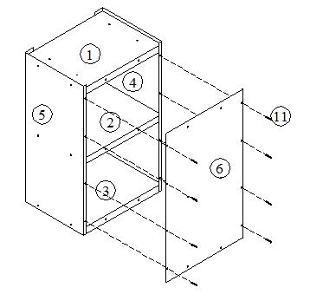
Figure 6
Attach the back panel (6) with 8 sheet metal screws (11) in the outside holes only. As shown in Figure 6.
DO NOT TIGHTEN THE SCREWS UNTIL FULLY ASSEMBLED
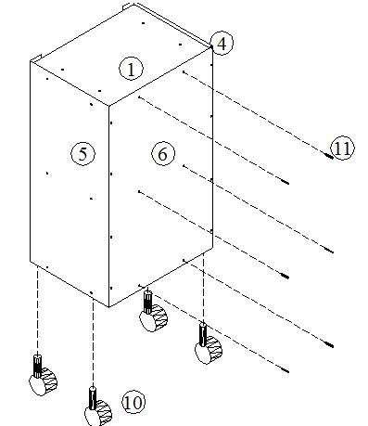
Figure 7
Install the final 6 sheet metal screws (11) through the back panel (6) into the three shelves.
Adjust the casters to the pedestal (10) by turning them clockwise to reduce their height and counter clockwise to increase the height. These adjustable feet will compensate for any irregularities in the surface you are putting it on. As shown in Figure 7.
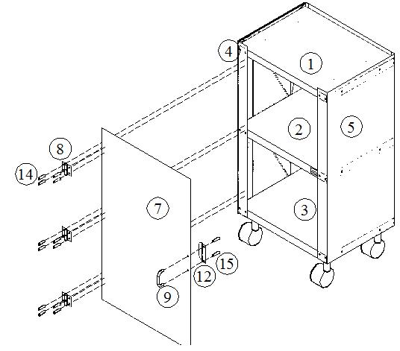
Figure 8
Attach the handle (9) to door (7) with handle support plate (12) and screws (15).
Attach 3 sets of hinge (8) to door (7) and left side panel (4) with screws (14).
DO NOT TIGHTEN THE SCREWS UNTIL FULLY ASSEMBLE
DO NOT TIGHTEN THE SCREWS UNTIL FULLY ASSEMBLED

Three Year Warranty

THE WARRANTY:
Benchmark USA warrants the original purchaser of new food equipment manufactured by Benchmark USA to be free from defects in material or workmanship from the date of the original purchase for a period of three years.

WHO IS COVERED BY THIS WARRANTY:
The original purchaser who has provided proper proof of the original retail purchase and all other requested information.

WHAT IS WARRANTIED:
The obligation of Benchmark USA under this warranty is limited to the replacement of any parts or components that in the opinion of Benchmark USA are defective, F.O.B. the factory, or at any other location that Benchmark USA may designate.

WHAT VOIDS THE WARRANTY:
1. Any piece of equipment that has been installed, operated or maintained inconsistently
with Benchmark USA operating instructions.
2. Any part or component that has been modified, changed or altered from its original
configuration.
3. Any electrical component that has been damaged due to submergence in any
liquid.
4. Any part or component that has been subject to abuse, misuse, neglect or
accidents.

EXTENT OF WARRANTY:
Any defective component, part or assembly returned to Benchmark USA will be replaced by Benchmark USA. Benchmark USA will not be responsible for any expenses incurred by the customer under the terms of this warranty, nor shall it be responsible for any damages either consequential, special, contingent, or otherwise; or expenses or injury arising directly or indirectly from the use of a Benchmark USA product. Any component, part or assembly returned to Benchmark USA must be returned at the customers expense along with proof of purchase. Benchmark USA reserves the right to determine whether the terms of this warranty have been properly complied with. In the event that the terms are not complied with, Benchmark USA shall be under no obligation to honor this warranty.

Benchmark USA Inc. ● 25-J Brookfield Oaks Dr. ● Greenville, SC 29607 ● T: 864-312-5500 ● F: 864-312-5505

