

OWNERS MANUAL
FOR POPCORN MACHINE PEDESTAL BASE

MODEL:
PEDESTAL BASE
Fits 4 or 6 ounce Premiere Poppers

PART NUMBER:
30080

INCLUDED:
PARTS LIST
ASSEMBLY INSTRUCTION
WARRANTY INFORMATION

Benchmark USA Inc. ● 25-J Brookfield Oaks Dr. ● Greenville, SC 29607 ● T: 864-312-5500 ● F: 864-312-5505

PARTS LIST
Part # / Item | Description
384 / 1 | Top Shelf (It has four holes in shelf surface) | 1 piece
385 / 2 | Middle shelf | 1 piece
386 / 3 | Bottom shelf (It has brackets to accept casters) | 1 piece
381 / 4 | Left side panel | 1 piece
382 / 5 | Right side panel | 1 piece
383 / 6 | Front panel with Decal | 1 piece
389 / 7 | M5 X 6mm Sheet metal screws | 38 pieces
387 / 8 | Casters | 4 sets

To order Parts Contact:
Benchmark USA, Inc.

25-J Brookfield Oaks Dr.
Greenville, SC 29607 USA
Tel: 877-432-5500
Fax: 864-312-5505
Email: parts@benchmarkusainc.com

Pedestal Assembly
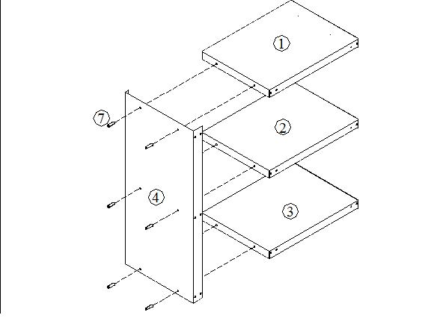
Figure 1
Assemble the pedestal by attaching the left side panel (4) to the top shelf (1), middle shelf (2) and bottom shelf (3) using the 6 of the enclosed sheet metal screws (7). As shown in Figure 1
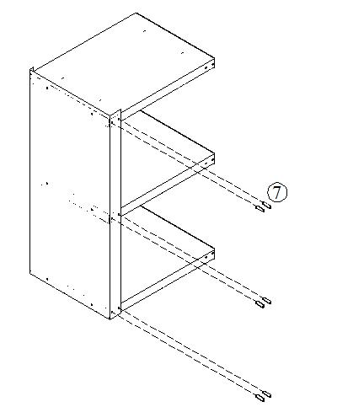Figure 2
Attach another 6 of the sheet metal screws (7) for front portion of left side panel (4). As shown in Figure 2
DO NOT TIGHTEN THE SCREWS UNTIL FULLY ASSEMBLED
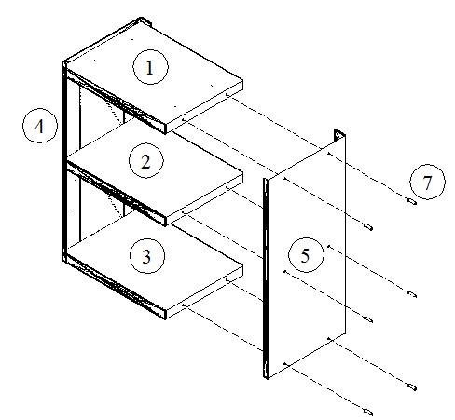Figure 3
Attach the right side panel (5) to the top shelf (1), middle shelf (2) and bottom shelf (3) using another 6 of the enclosed sheet metal screws (7). As shown in Figure 3
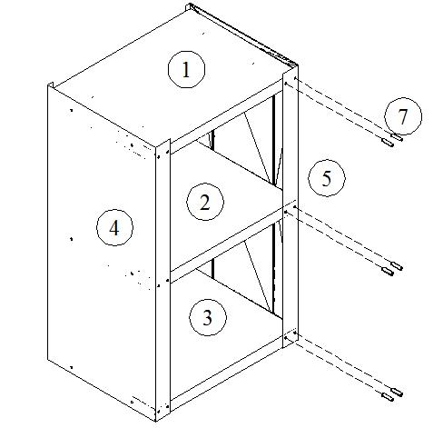
Figure 4
Attach 6 of the sheet metal screws (7) for front portion of right side panel (5). As shown in Figure 4
DO NOT TIGHTEN THE SCREWS UNTIL FULLY ASSEMBLED
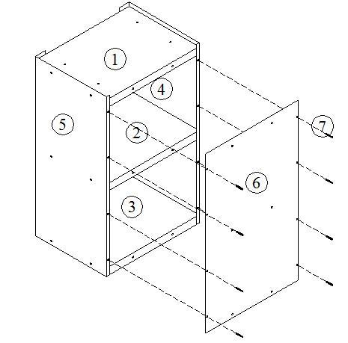Figure 5
Attach the front panel with Decal (6) with 8 of the sheet metal screws (7) in the outside holes only. As shown in Figure 5
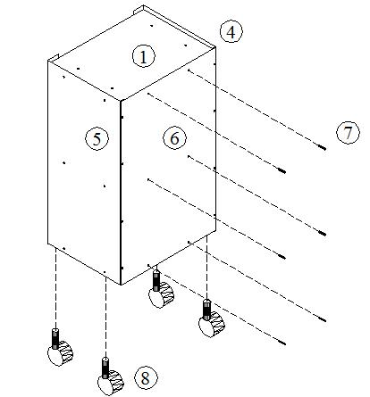
Figure 6
Install the final 6 sheet metal screws (7) through the front panel (6)and into the shelves.
Adjust the wheels of pedestal (8) by turning them clockwise to reduce their height and counter clockwise to increase the height. These adjustable feet will compensate for any irregularities in the surface you are putting it on. As shown in Figure 6.
DO NOT TIGHTEN THE SCREWS UNTIL FULLY ASSEMBLED

Three Year Warranty

THE WARRANTY:
Benchmark USA warrants the original purchaser of new food equipment manufactured by Benchmark USA to be free from defects in material or workmanship from the date of the original purchase for a period of three years.

WHO IS COVERED BY THIS WARRANTY:
The original purchaser who has provided proper proof of the original retail purchase and all other requested information.

WHAT IS WARRANTIED:
The obligation of Benchmark USA under this warranty is limited to the replacement of any parts or components that in the opinion of Benchmark USA are defective, F.O.B. the factory, or at any other location that Benchmark USA may designate.

WHAT VOIDS THE WARRANTY:
1. Any piece of equipment that has been installed, operated or maintained inconsistently
with Benchmark USA operating instructions.
2. Any part or component that has been modified, changed or altered from its original
configuration.
3. Any electrical component that has been damaged due to submergence in any
liquid.
4. Any part or component that has been subject to abuse, misuse, neglect or
accidents.

EXTENT OF WARRANTY:
Any defective component, part or assembly returned to Benchmark USA will be replaced by Benchmark USA. Benchmark USA will not be responsible for any expenses incurred by the customer under the terms of this warranty, nor shall it be responsible for any damages either consequential, special, contingent, or otherwise; or expenses or injury arising directly or indirectly from the use of a Benchmark USA product. Any component, part or assembly returned to Benchmark USA must be returned at the customers expense along with proof of purchase. Benchmark USA reserves the right to determine whether the terms of this warranty have been properly complied with. In the event that the terms are not complied with, Benchmark USA shall be under no obligation to honor this warranty.

Benchmark USA Inc. ● 25-J Brookfield Oaks Dr. ● Greenville, SC 29607 ● T: 864-312-5500 ● F: 864-312-5505

